
Dashboard Design

Date | 28 August 2026
Team ID | ____________
Project Name | AI Adoption and Impact in Global Education
Maximum Marks | 5 Marks

Creating an effective dashboard involves thoughtful design to ensure that the presented information is clear, relevant, and easily understandable for the intended audience. Here are some key principles and best practices for dashboard design
Activity 1: Interactive and visually appealing dashboards
Activity 2
Publish Dashboard on Tableau Public and Paste the Dashboard Public link below:
Example
https://public.tableau.com/views/SalesDashboard_17247660582000/Dashboard1?:language=en-US&publish=yes&:sid=&:redirect=auth&:display_count=n&:origin=viz_share_link
• Clear and Intuitive Layout: Organize the dashboard into a clear hierarchy: title and KPI cards at the top, major adoption comparisons in the central area, geographic/regional analysis below, and detailed supporting visuals at the bottom.
• Use Appropriate Visualizations: Use KPI cards for overall adoption indicators, bar charts for country/region comparisons, maps for geographic patterns, line or trend charts where a time field is available, scatter plots for relationships between adoption and infrastructure indicators, and heatmaps for demographic comparisons.
• Colour and Theming: Use a consistent professional theme throughout the Tableau dashboard. Maintain readable contrast, use a limited colour palette, and keep the same meaning for colours across charts.
• Interactive Filters and Slicers: Provide filters for country, region, demographic group, AI tool, student/teacher group, and other relevant fields available in the dataset. Filters should update related visuals.
• Drill-Down Capabilities: Allow users to move from global or regional summaries to country-level details where the Tableau data structure supports drill-down.
• Responsive Design: Design the dashboard so charts, KPI cards, labels, and filters remain readable on common desktop screen sizes and do not overlap.
• Custom Visuals and Icons: Use simple icons or visual indicators for major measures such as student adoption, teacher adoption, school adoption, internet penetration, and education index where appropriate.
• Use of Infographics: Use concise annotations, KPI cards, and callout sections to communicate important findings without overcrowding the dashboard.
Suggested Dashboard Structure
• Dashboard 1 – Global Overview: KPI cards, global/regional adoption, country map, and key filters.
• Dashboard 2 – Adoption Analysis: student vs teacher adoption, school adoption, AI tool usage, and daily usage time.
• Dashboard 3 – Infrastructure & Policy: internet penetration, education index, government policy indicators, and adoption relationships.
• Dashboard 4 – Demographic & Regional Gaps: demographic comparisons, regional disparities, and focused filters.
Major Outcomes
• The dashboard will provide a clear overview of AI adoption among students, teachers, and schools across countries and regions.
• Country and regional comparisons will help identify areas with relatively high or low AI adoption.
• AI tool usage and daily usage-time visuals will show differences in how educational AI is being used.
• Infrastructure and education indicators can be compared with AI adoption to identify potential relationships and patterns.
• Government policy information can be viewed alongside adoption indicators to support analysis of policy environments.
• Demographic and regional views will help identify potential adoption gaps and support discussion of equitable AI integration.
• Interactive filters and drill-downs will allow different stakeholders to explore the data according to their specific needs.
Publish the completed dashboard on Tableau Public and paste the public dashboard link below.
Tableau Public Dashboard Link: https://public.tableau.com/app/profile/prathmesh.waghmare3827/viz/ProjectDashboard_17874360763640/Dashboard1
Dashboard Screenshot(s): 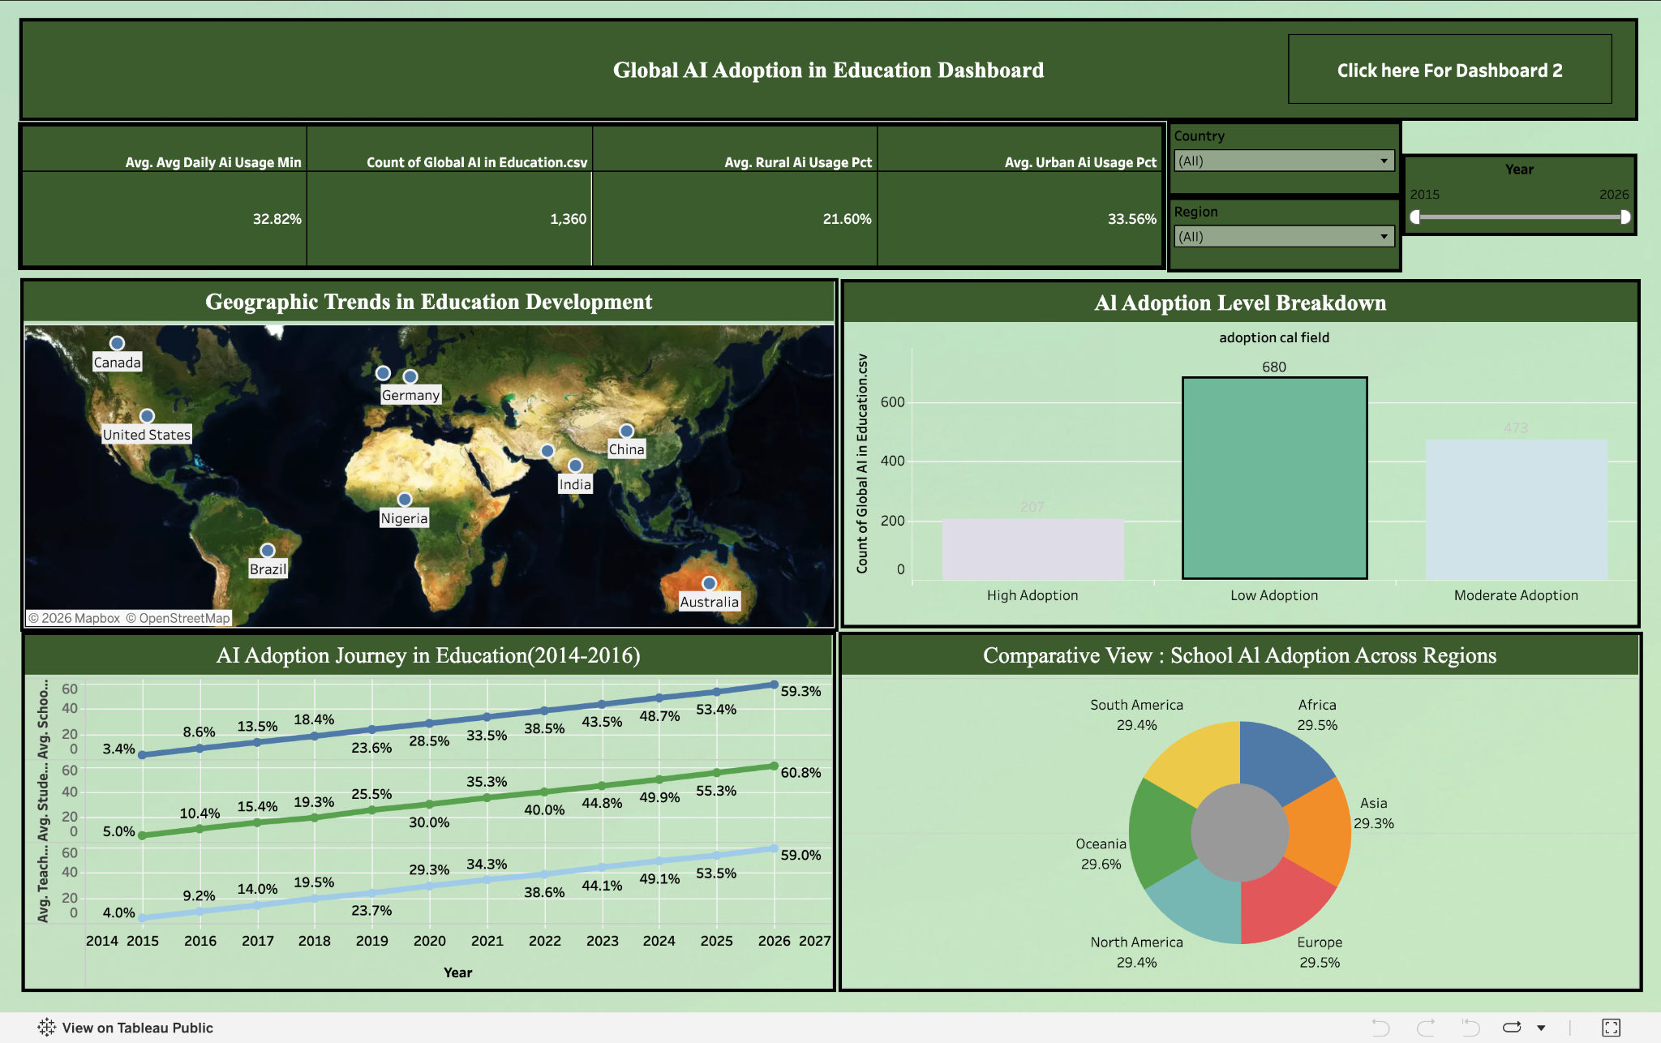
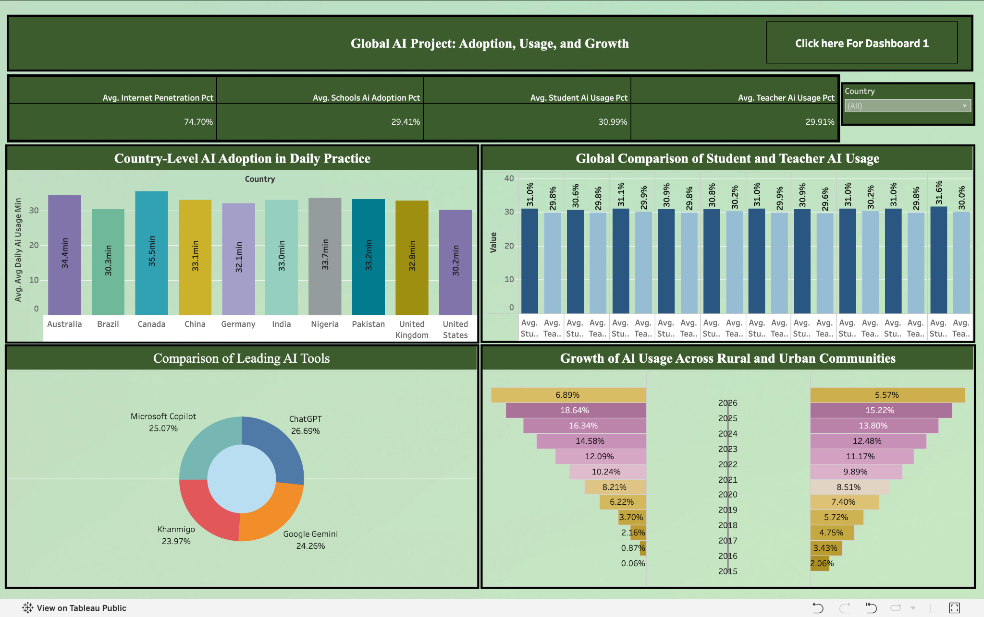

Note: Actual dashboard values and outcomes should be updated after the Tableau visualizations are finalized. No numerical results have been invented in this report.

